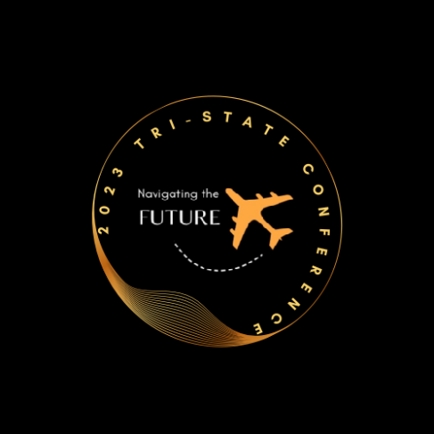

Business Partner Options
Fall 2023 Tri-State Conference
October 29, 2023 – October 31, 2023

Business Partner Sponsorship/Exhibitor Fee ($1,000)
Includes 6' x 30" table within the Ballroom (around the border of the room) where all general sessions will take place, as well as the meals.

Lanyards ($250)
Your company can be the sole sponsor to bring your branded lanyards (about 125) that will be given to each conference attendee to be attached to their name tag.

Sponsored Breaks ($250)
We have 3 breaks during this year's conference. We are offering up to 3 sponsors the opportunity to 1 break each. Your company logo will be displayed during the break and you will be provided with verbal recognition at the conference.

Sunday Night Happy Hour ($450)
We are offering up to 2 sponsors for the Sunday night happy hour that will include a drink ticket for each attendee.

Monday Night Happy Hour ($450)
We are offering up to 2 sponsors for the Monday night happy hour that will include a drink ticket for each attendee.

Water Bottles ($500)
Your company can be the sole sponsor to bring your branded water bottles (about 125) that will be inserted in each conference welcome bag for attendees.

Wifi Password ($500)
Your company name will be set up as the Wifi password for the conference event.

Conference Bags ($500)
Your company can be the sole sponsor to bring your own branded bags (about 125) that will be given to each conference attendee when they check into the conference.

Sunday Night Entertainment ($500)
We are offering 1 sponsorship for the Sunday night entertainment on 10/29/23. We will provide signage with your company logo, as well as verbal recognition and recognition within the agenda that will be posted on the DEDCMD ASFAA website.

Monday Night Entertainment ($750)
We are planning activities for Monday night entertainment, including a DJ (same one as last year!). This sponsor will be given verbal recognition, as well as signage for their sponsorship of these activities that evening.

